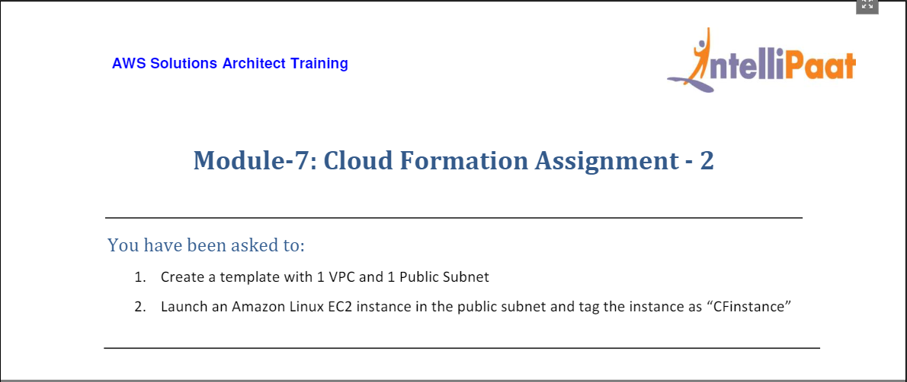

1. For this we head to CloudFormation from Console home and then click on Create Stack.

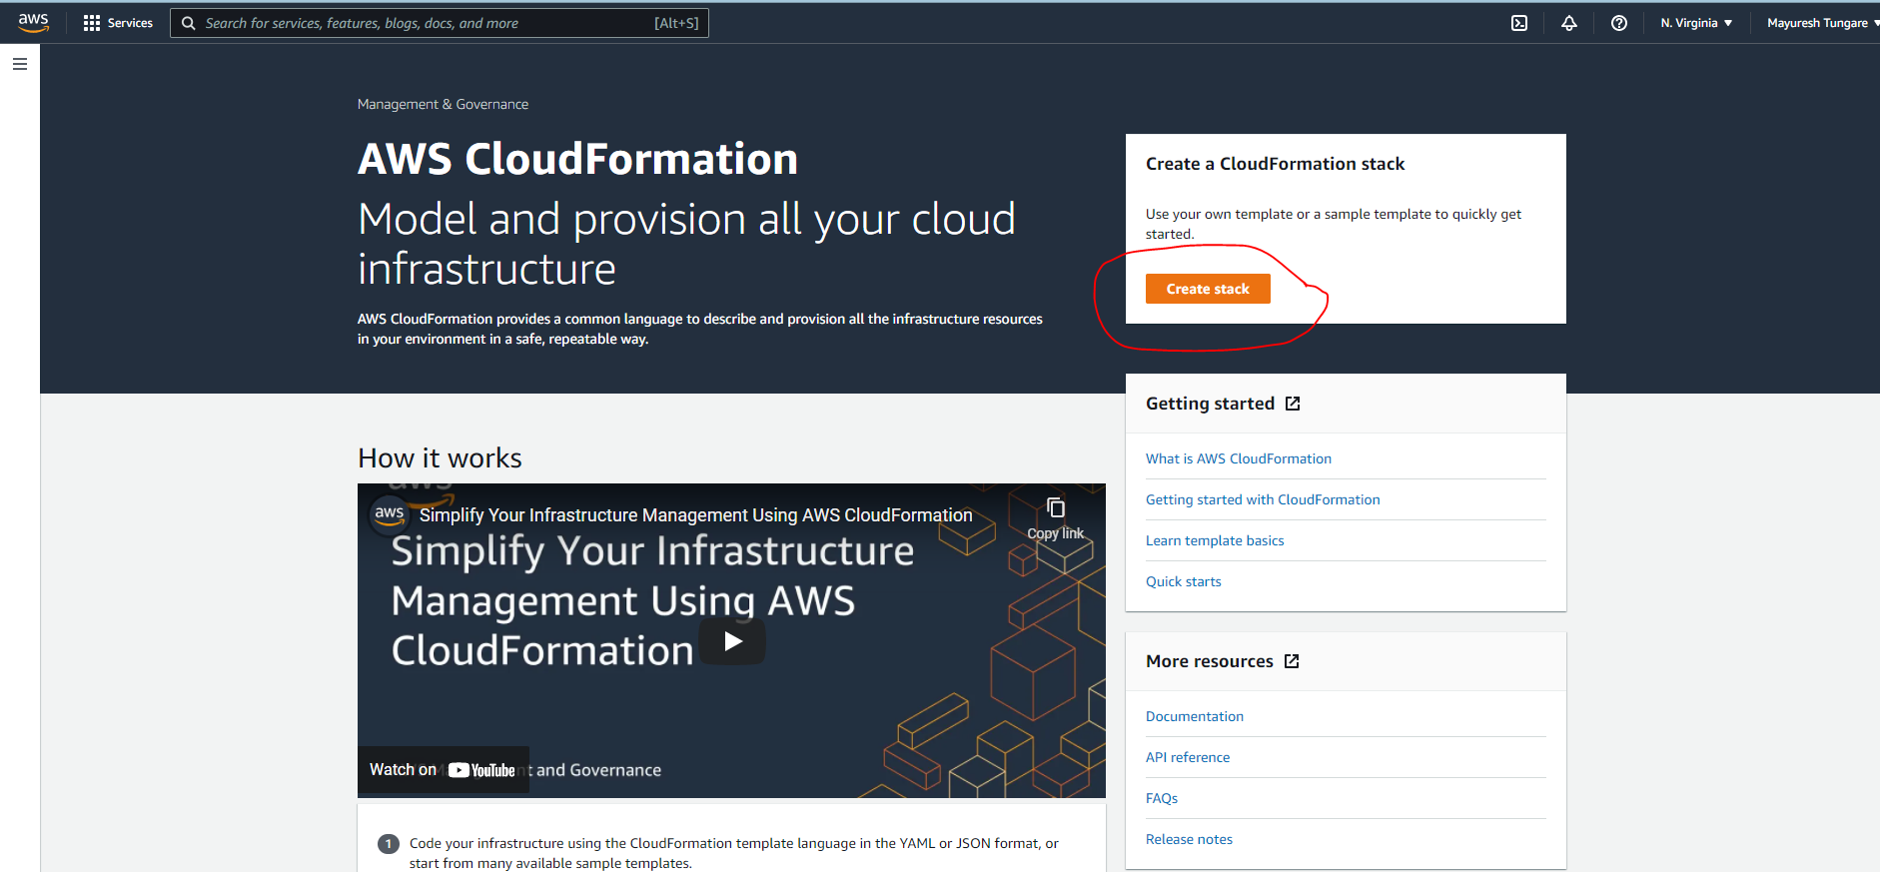

1. We then create the following Yaml template to launch details as below:

VPC: mod7ass2vpc

Subnet: mod7ass2publicsubnet

RouteTable: mod7ass2publicroutetable

Internet Gateway: mod7ass2internetgw

EC2 instance: mod7ass2instance (add key tag ‘CF Instance’)

AZ: us-east-1a

Imageid: ami-0bebcdc3f3038fbce

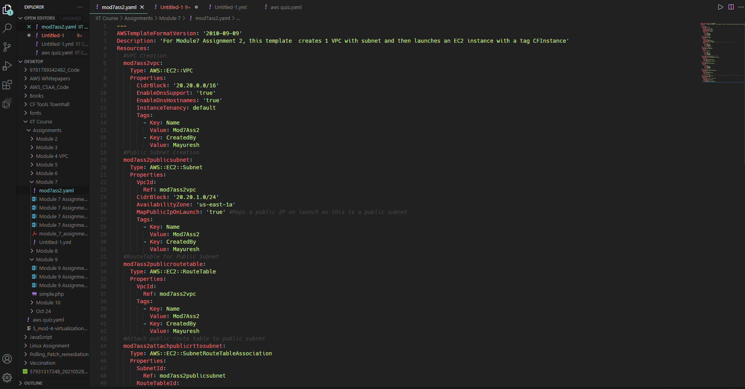

1. After we click on ‘Create stack’ from step 1, we see the next screen where enter details as below and click on ‘Next’:

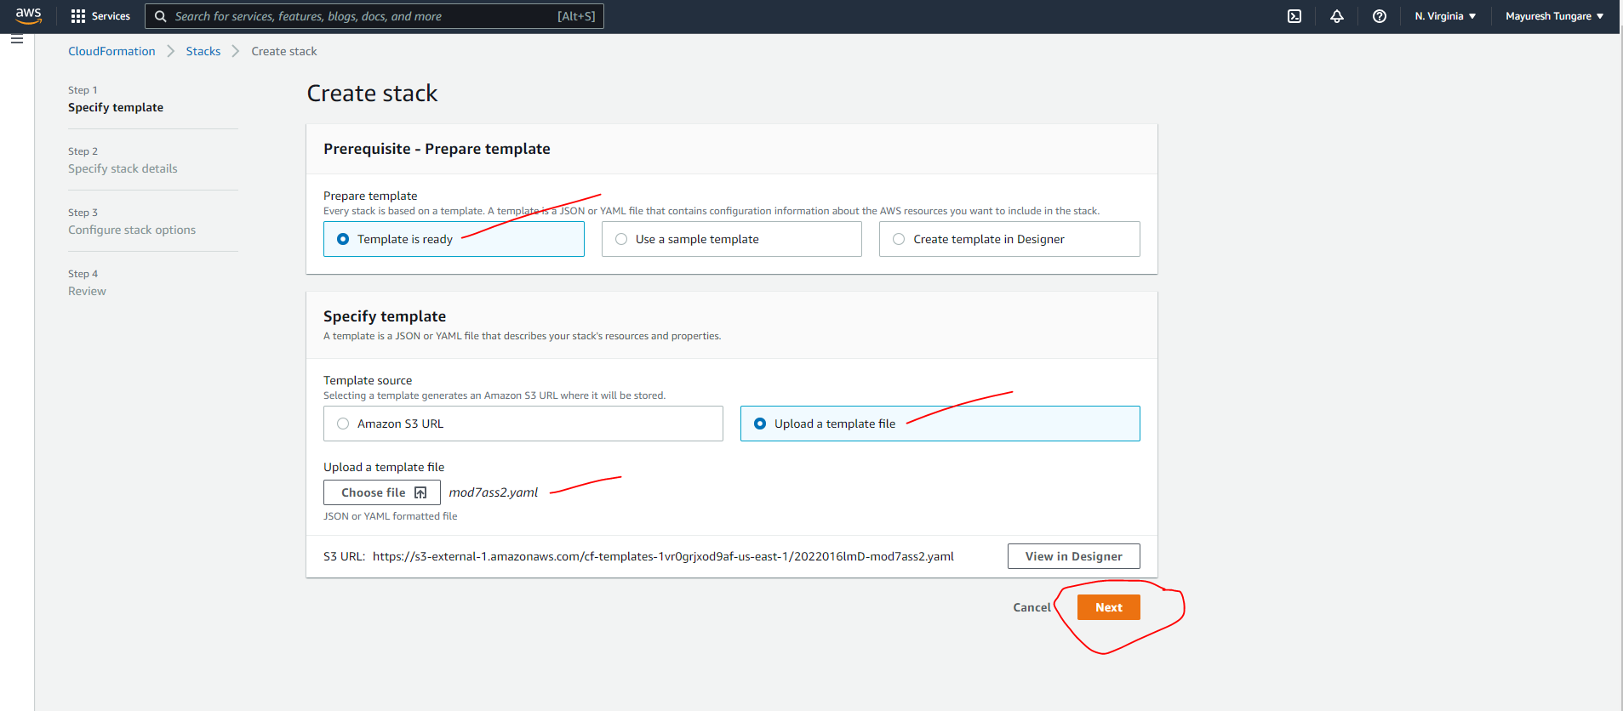

1. On the next screen, we provide a stackname and then click next. Refer below:

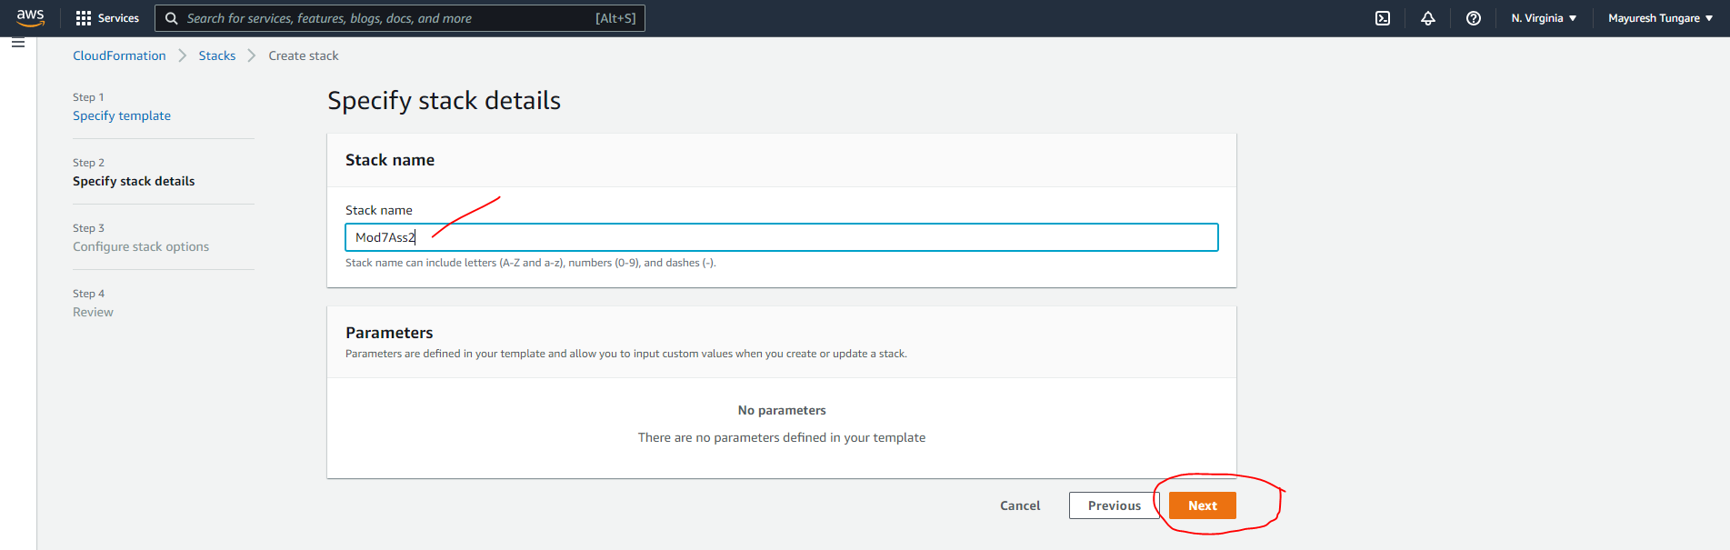

1. On the next screen, we make no changes and let all settings remain as is and then click on next.

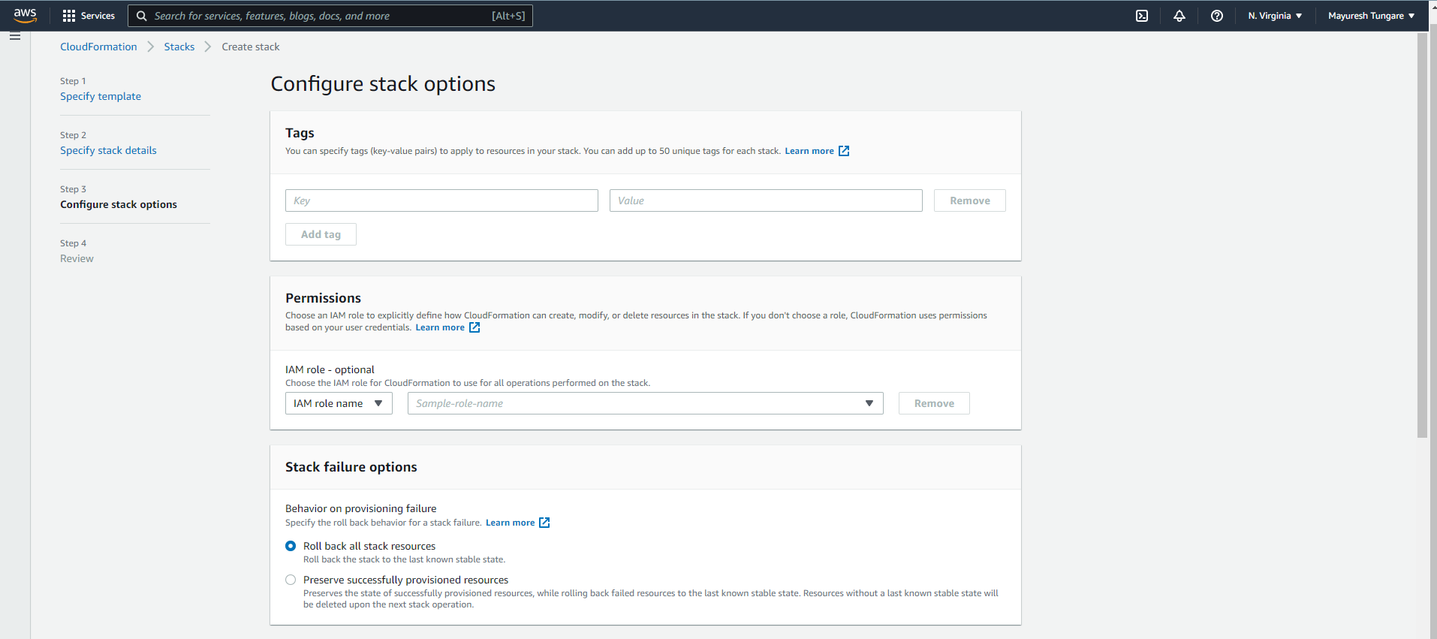

1. On the next screen, we see all the components being created as follows:

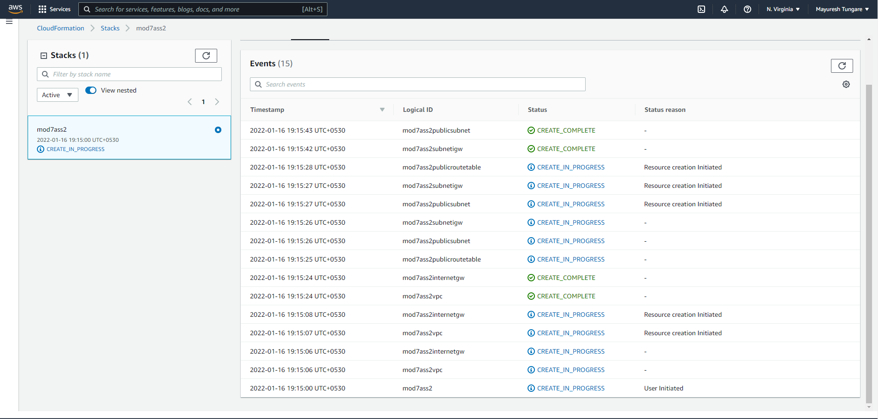

1. Thus the assignment is now complete.